DATE:29/12/2025 Day 2 – Querying &amp; Modifying Data ABHISHEK ALLABOINA
https://learn.microsoft.com/en-us/sql/t-sql/language-reference?view=sql-server-ver17

--1) creation of database
CREATE DATABASE InsuranceDB;

USE InsuranceDB;

--2) creation of tables with relationships and constraints
CREATE TABLE Customers (
CustomerID INT IDENTITY(1,1) CONSTRAINT PK_Customers PRIMARY KEY,
FirstName VARCHAR(20) NOT NULL,
LastName VARCHAR(20),
DateOfBirth DATE,
Phone VARCHAR(20),
Email VARCHAR(20) UNIQUE
);

CREATE TABLE Policies (
PolicyID INT IDENTITY(1,1) CONSTRAINT PK_Policies PRIMARY KEY,
PolicyName VARCHAR(20),
PolicyType VARCHAR(20),
PremiumAmount DECIMAL(10,2),
DurationYear INT
);

CREATE TABLE Agents (
AgentID INT IDENTITY(1,1) CONSTRAINT PK_Agents PRIMARY KEY,
AgentName VARCHAR(20),
Phone VARCHAR(15),
City VARCHAR(20)
);

CREATE TABLE PolicyAssignments (
AssignmentID INT IDENTITY(1,1) CONSTRAINT PK_PolicyAssignments PRIMARY KEY,
CustomerID INT,
PolicyID INT,
AgentID INT,
StartDate DATE,
EndDate DATE,

CONSTRAINT FK_PolicyAssignments_Customers
FOREIGN KEY (CustomerID) REFERENCES Customers(CustomerID),

CONSTRAINT FK_PolicyAssignments_Policies
FOREIGN KEY (PolicyID) REFERENCES Policies(PolicyID),

CONSTRAINT FK_PolicyAssignments_Agents
FOREIGN KEY (AgentID) REFERENCES Agents(AgentID)
);

CREATE TABLE Claims (
ClaimID INT IDENTITY(1,1) CONSTRAINT PK_Claims PRIMARY KEY,
AssignmentID INT,
ClaimDate DATE,
ClaimAmount DECIMAL(10,2),
ClaimStatus VARCHAR(20),

CONSTRAINT FK_Claims_PolicyAssignments
FOREIGN KEY (AssignmentID) REFERENCES PolicyAssignments(AssignmentID)
);

INSERT INTO Customers (FirstName, LastName, DateOfBirth, Phone, Email)
VALUES
('Abhi', 'Shek', '2004-07-03', '7075268421', 'abhishek@gmail.com'),
('Santhu', 'Chepuri', '2004-05-24', '9080706050', 'chepuri@gmail.com');

INSERT INTO Policies (PolicyName,PolicyType,PremiumAmount,DurationYear)
VALUES
('Life Term', 'Life', 15000.00, 20),
('Health Plus', 'Health', 12000.00, 10);

INSERT INTO Agents (AgentName, Phone, City)
VALUES
('Spoorthik', '7867867867', 'Karachi'),
('Idries', '7867867866', 'Rawalpindi');

INSERT INTO PolicyAssignments
(CustomerID, PolicyID, AgentID, StartDate, EndDate)
VALUES
(1, 1, 1, '2025-01-01', '2045-01-01'),
(2, 2, 2, '2025-06-01', '2035-06-01');

INSERT INTO Claims
(AssignmentID, ClaimDate, ClaimAmount, ClaimStatus)
VALUES
(1, '2026-02-15', 50000.00, 'Approved'),
(2, '2026-03-10', 30000.00, 'Pending');

INSERT INTO Customers (FirstName, LastName, DateOfBirth, Phone, Email)
VALUES
('Varun', 'Kumar', '1999-08-12', '9001112233', 'varun@gmail.com'),
('Bhanu', 'Prakash', '1998-03-25', '9002223344', 'bhanu@gmail.com'),
('Ramu', 'Reddy', '2000-12-05', '9003334455', 'ramu@gmail.com');

INSERT INTO Policies (PolicyName, PolicyType, PremiumAmount, DurationYear)
VALUES
('Life Term', 'Life', 18000.50, 25),
('Health Shield', 'Health', 9500.75, 12),
('Car Protect', 'Vehicle', 7200.00, 5);

INSERT INTO Agents(AgentName,Phone,City)
VALUES
('Anil', '9876543210', 'Delhi'),
('Suresh', '9223344556', 'Hyderabad');

INSERT INTO PolicyAssignments
(CustomerID, PolicyID, AgentID, StartDate, EndDate)
VALUES
(3, 3, 1, '2023-01-10', '2048-01-10'),
(4, 4, 2, '2024-06-15', '2036-06-15'),
(5, 5, 1, '2025-03-01', '2030-03-01');

INSERT INTO Claims
(AssignmentID, ClaimDate, ClaimAmount, ClaimStatus)
VALUES
(3, '2024-11-20', 45000.00, 'Approved'),
(4, '2025-07-05', 15000.00, 'Rejected'),
(5, '2025-09-18', 8000.00, 'Pending');

INSERT INTO Customers (FirstName, LastName, DateOfBirth, Phone, Email)
VALUES
('sangu', 'Rao', '2002-02-10', '9876543210', 'sangu@gmail.com'),
('Manu', 'pal', '1998-11-15', '9876543211', 'manu@gmail.com');

INSERT INTO Policies (PolicyName, PolicyType, PremiumAmount, DurationYear)
VALUES
('Motor Secure', 'Motor', 11000.00, 1),
('Family Health', 'Health', 20000.00, 1);

INSERT INTO Agents (AgentName, Phone, City)
VALUES
('Rakesh', '9112233445', 'Bangalore'),
('Ajay', '9887766554', 'Chandigarh');

INSERT INTO PolicyAssignments (CustomerID, PolicyID, AgentID, StartDate, EndDate)
VALUES
(1, 6, 3, '2024-01-01', '2025-01-01'),
(2, 7, 4, '2025-02-01', '2026-02-01'),
(6, 4, 3, '2023-05-10', '2035-05-10');

INSERT INTO Claims (AssignmentID, ClaimDate, ClaimAmount, ClaimStatus)
VALUES
(6, '2025-03-15', 60000.00, 'Approved'),
(7, '2025-05-20', 25000.00, 'Rejected');

4.SELECT COMMANDS:
4.1: SELECT * FROM Customers;
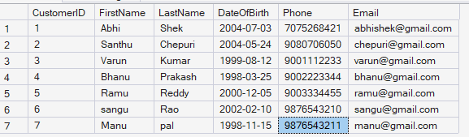
4.2: SELECT CustomerID, PolicyID, StartDate, EndDate FROM PolicyAssignments;
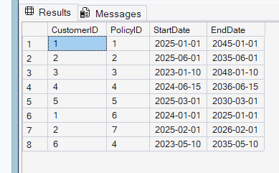
4.3 SELECT * FROM Policies WHERE PolicyType='Health';
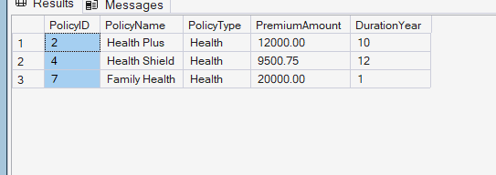
4.4: Select * from Policies Where PremiumAmount>10000 AND DurationYear=1;
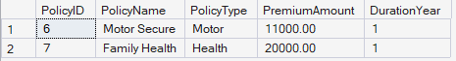
4.5: SELECT DISTINCT City FROM Agents;
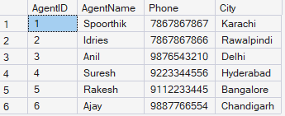
4.6: SELECT * FROM Policies
WHERE PolicyType='Life' OR PolicyType='Health' OR PolicyType='Motor';
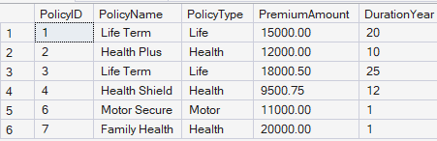
4.7: SELECT * FROM Policies
WHERE PolicyType IN ('Life','Health','Motor');
4.8: SELECT * FROM Customers
WHERE DateOfBirth >= '2001-01-01'
AND DateOfBirth <= '2020-12-31';
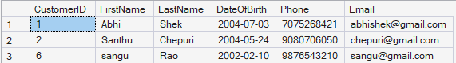
4.9: SELECT * FROM Customers
WHERE DateOfBirth BETWEEN'2001-01-01'
AND '2020-12-31';
4.10: SELECT * FROM Claims WHERE ClaimStatus='Rejected'; 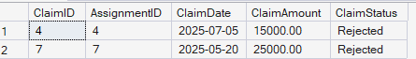
4.11: SELECT * FROM Agents
WHERE City LIKE '_a%';
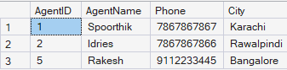
4.12 select max(ClaimAmount) as HighestClaim,min(ClaimAmount) as LowestClaim
from Claims;
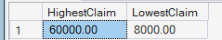
4.13: select top 1* from Claims
order by ClaimDate;
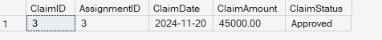
4.14: UPDATE Policies
SET PremiumAmount=PremiumAmount*1.10
WHERE PolicyType='Health';
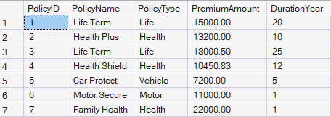
4.15 DELETE FROM PolicyAssignments
WHERE EndDate < GETDATE();
error:
Msg 547, Level 16, State 0, Line 236
The DELETE statement conflicted with the REFERENCE constraint "FK_Claims_PolicyAssignments". The conflict occurred in database "InsuranceDB", table "dbo.Claims", column 'AssignmentID'.
The statement has been terminated.
DELETE FROM Claims
WHERE AssignmentID IN (
SELECT AssignmentID
FROM PolicyAssignments
WHERE EndDate < GETDATE()
);
DELETE FROM PolicyAssignments
WHERE EndDate < GETDATE();



4.16:
SELECT COUNT(*) AS RejectedClaims
FROM Claims
WHERE ClaimStatus = 'Rejected';
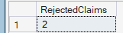
4.17:
select PolicyID,PolicyName,PremiumAmount, PremiumAmount*0.06 AS LocalTaxes,
PremiumAmount*1.06 AS PremiumTaxes,
(PremiumAmount*1.06)/12 AS Montly
FROM Policies;
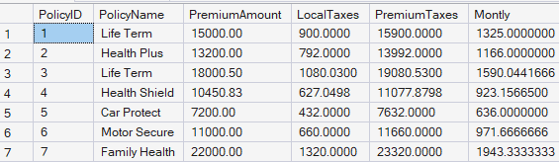
4.18: ALTER table customers ADD Address VARCHAR(50), City VARCHAR(20);
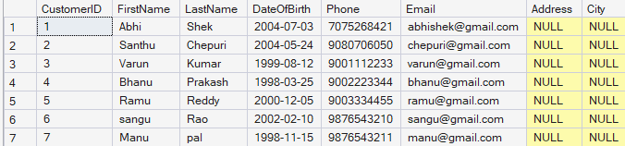
4.19: ALTER TABLE Agents ADD DevOfId INT;
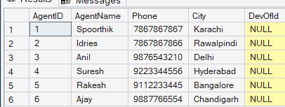
4.20:
ALTER TABLE Agents
ADD CONSTRAINT FK_Agents_DevOfId
FOREIGN KEY (DevOfId) REFERENCES Agents(AgentID);

5) QUERIES USING HAVING ,GROUPBY
5.1:
SELECT p.* FROM Policies p JOIN PolicyAssignments pa ON p.PolicyID = pa.PolicyID WHERE pa.CustomerID = 5;
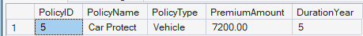
5.2:
select FirstName,PolicyName FROM Customers c JOIN PolicyAssignments pa
on c.CustomerID=pa.CustomerID
JOIN Policies p
on p.PolicyID=pa.PolicyID;

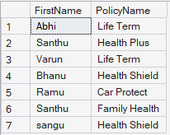

5.3 select c.FirstName,cl.ClaimAmount,cl.ClaimStatus from
Claims cl
join PolicyAssignments pa on cl.AssignmentID=pa.AssignmentID
join Customers c on pa.CustomerID=c.CustomerID;
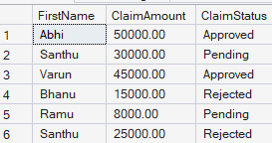
5.4:
select FirstName,PolicyName,AgentName,StartDate,EndDate
FROM PolicyAssignments pa
join Customers c on pa.CustomerID=c.CustomerID
join Policies p on pa.PolicyID=p.PolicyID
join Agents a on pa.AgentID=a.AgentID;
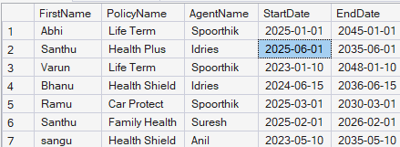

5.5: SELECT c.FirstName, p.PolicyName,
cl.ClaimAmount, cl.ClaimStatus, cl.ClaimDate
FROM Claims cl
JOIN PolicyAssignments pa ON cl.AssignmentID = pa.AssignmentID
JOIN Customers c ON pa.CustomerID = c.CustomerID
JOIN Policies p ON pa.PolicyID = p.PolicyID; 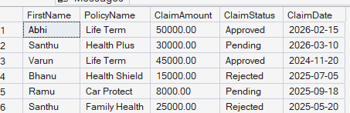
5.6: SELECT c.CustomerID,c.FirstName,p.PolicyName,p.PolicyID
FROM Customers c
LEFT JOIN PolicyAssignments pa ON c.CustomerID = pa.CustomerID
LEFT JOIN Policies p ON pa.PolicyID = p.PolicyID;
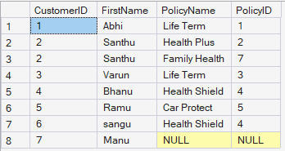
5.7: select c.* from Customers c
left join PolicyAssignments pa on c.CustomerID=pa.CustomerID
left join Claims cl on cl.AssignmentID=pa.AssignmentID
where cl.ClaimID is null;

5.8:select concat(c.FirstName,c.LastName) as FullName,
sum(cl.ClaimAmount) as TotalClaim
from Customers c
join PolicyAssignments pa on pa.CustomerID=c.CustomerID
join Claims cl on cl.AssignmentID=pa.AssignmentID
group by c.FirstName,c.LastName
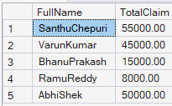
5.9: select concat(c.FirstName,c.LastName) as FullName,
sum(cl.ClaimAmount) as TotalClaim
from Customers c
join PolicyAssignments pa on pa.CustomerID=c.CustomerID
join Claims cl on cl.AssignmentID=pa.AssignmentID
group by c.FirstName,c.LastName
having sum(cl.ClaimAmount)>50000;
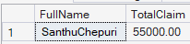
5.10: SELECT a.AgentName,COUNT(pa.AgentID) AS PolicyCount
FROM Agents a
JOIN PolicyAssignments pa
ON
a.AgentID=pa.AgentID
group by a.AgentID,a.AgentName;
